Day 25 Highlights

1. Reminders
   1. Project 5 to be posted Wednesday
   2. Lab Six this week
   3. Quiz this Fiday
   4. No zyBooks exercises due next Monday
2. View a 2D array as an array of 1D arrays and allocate the space on the heap
   1. Declare the array

**int **array;**

* 1. Allocate the “backbone” (one item for each row)

**array = malloc(sizeof(int *) * numRows);**

* 1. Allocate “all the columns for that row”

**for (a=0; a<numRows; a++)**

**array[a] = malloc(sizeof(int) * numCols);**

1. Write some more functions (sum, avg, min, max) of a 2D array
2. How to free space for such a 2D array?

**A 2D array is an array of 1D arrays.**

int numRows, numCols;

int **array;

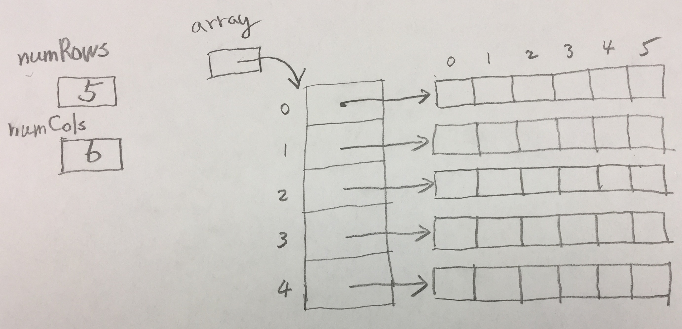

int main(int argc, char **argv) {}

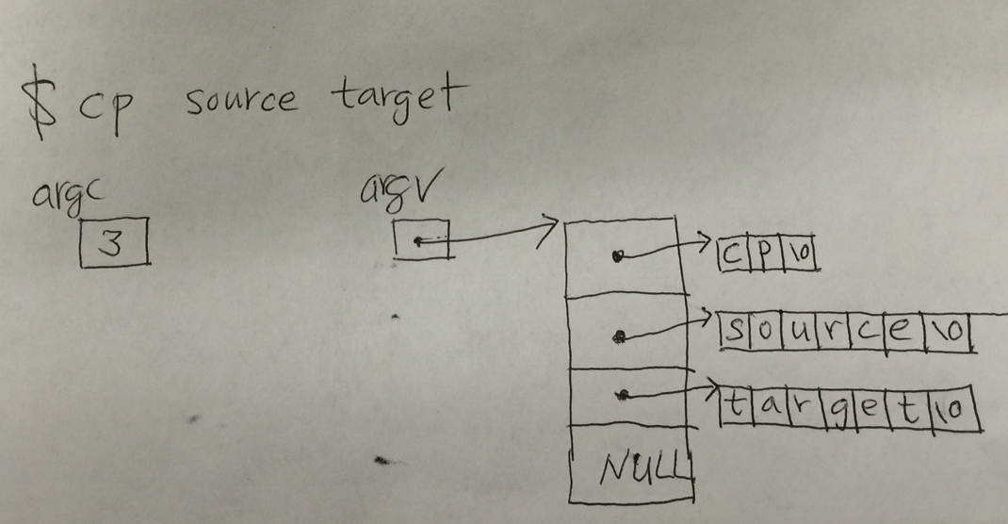

What is argv[2][4]?